IILM UNIVERSITY, GREATER NOIDA
School of Computer Science and Engineering
INTERNSHIP REPORT
Artificial Intelligence Internship
Codec Technologies Pvt. Ltd.
Internship Period: 17/07/2026 to 17/08/2026
Submitted by
Anish Kumar
Roll No.: 25SCS1003005437
B.Tech Computer Science and Engineering – AI & ML

1. DECLARATION
I, Anish Kumar, hereby declare that this internship report is a record of the learning and project work completed by me during the one-month Artificial Intelligence Internship at Codec Technologies Pvt. Ltd.
This report has been prepared for academic submission as a part of my B.Tech programme in Computer Science and Engineering – Artificial Intelligence & Machine Learning.
The report presents my understanding of Artificial Intelligence concepts, Python programming, Natural Language Processing, AI-based text processing, machine learning fundamentals and project-related activities covered during the internship.
The technical information and references used while preparing this report have been appropriately acknowledged.
I further declare that this report has not been submitted by me to any other institution for the award of any degree, diploma or academic qualification.
Name: Anish Kumar
Roll No.: 25scs1003005437
Signature: __________________
2. ACKNOWLEDGEMENT
I sincerely express my gratitude to Codec Technologies Pvt. Ltd. for providing me with the opportunity to participate in the one-month Artificial Intelligence Internship programme.
The internship provided me with valuable practical exposure to Artificial Intelligence and helped me understand how AI concepts can be applied to real-world problems. It allowed me to connect the concepts studied during my academic curriculum with practical implementation and project development.
During the internship, I gained knowledge about Python programming, Artificial Intelligence, Natural Language Processing, text processing, information extraction and AI-assisted decision-making. I also developed an understanding of how AI components can be integrated with web applications and databases.
I am thankful to the mentors and instructors associated with the internship programme for their guidance and support throughout the learning process. Their guidance helped me understand different stages of AI project development, including problem identification, data processing, model-related concepts, implementation, testing and evaluation.
I would also like to express my gratitude to the School of Computer Science and Engineering, IILM University, Greater Noida, for providing academic support and encouragement.
Finally, I am thankful to my parents, friends and everyone who motivated and supported me throughout this internship.
ANISH KUMAR
3. CONTENTS
- Declaration
- Acknowledgement
- Contents
- Internship Certificate
- Overview of the Internship
- 5.1 About the Training Organization
- 5.2 Internship Learning Areas
- Project Study
- 6.1 Project Background
- 6.2 Need for the Proposed System
- 6.3 Project Goals
- 6.4 Functional Scope
- 6.5 Technology Stack
- 6.6 Overall Design
- 6.7 Development Approach
- 6.8 Major Components
- 6.9 Anticipated Results
- 6.10 Summary
- References
4. INTERNSHIP CERTIFICATE
The internship certificate issued by Codec Technologies Pvt. Ltd. confirms the completion of the one-month AICTE & ICAC Approved Internship Programme.
The certificate identifies ANISH KUMAR as an Artificial Intelligence Intern and records the internship period from 17/07/2026 to 17/08/2026.
The internship provided practical exposure to Artificial Intelligence concepts and their application in software-based problem solving.
Certificate of Internship
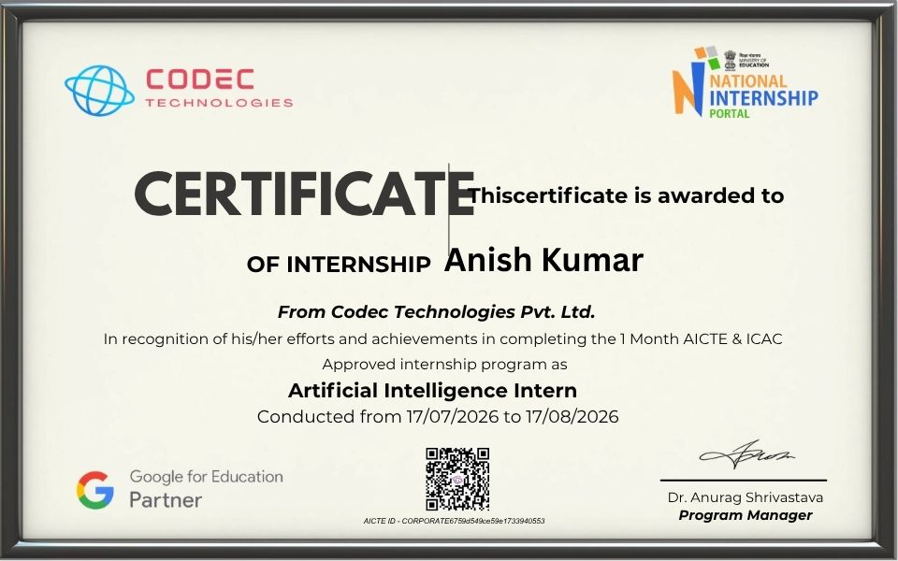

Internship Offer Letter
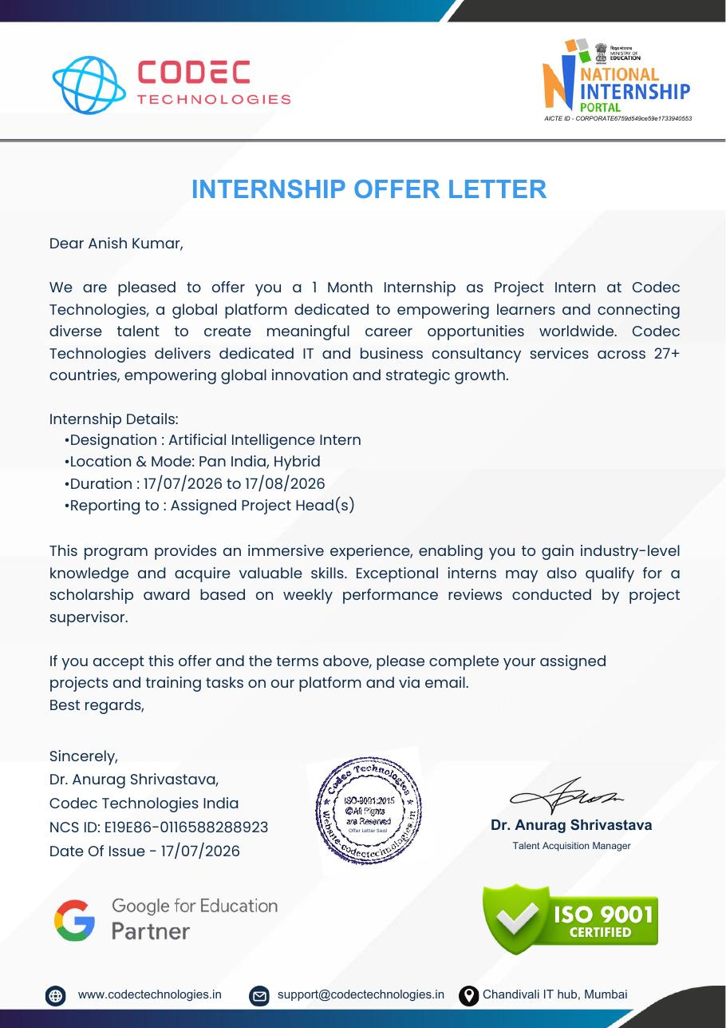
5. OVERVIEW OF THE INTERNSHIP
5.1 About the Training Organization
Codec Technologies Pvt. Ltd. was the organization through which the Artificial Intelligence internship programme was undertaken.
The internship programme was designed to provide practical exposure to Artificial Intelligence concepts and the development workflow used for AI-based applications.
The learning process introduced fundamental concepts of AI and gradually moved towards their practical application. The programme provided exposure to Python programming, Artificial Intelligence, Natural Language Processing, text processing, information extraction and AI-assisted application development.
The internship also provided an understanding of how an AI component can communicate with other software components through APIs and databases. This helped in understanding the complete workflow of an AI-enabled software application.
The structured learning approach helped in understanding how an AI project can be developed from problem identification and data processing to implementation, testing and final evaluation.
5.2 Internship Learning Areas
During the internship, the major areas of learning included:
- Understanding the fundamentals of Artificial Intelligence.
- Learning Python programming for AI-related applications.
- Understanding the basic concepts of Machine Learning.
- Learning Natural Language Processing concepts.
- Understanding text preprocessing techniques.
- Working with textual data and extracting useful information.
- Understanding resume and document processing.
- Identifying relevant skills and information from text.
- Understanding AI-assisted candidate screening.
- Learning the concept of matching candidate information with job requirements.
- Understanding candidate ranking using extracted information.
- Learning about API-based communication using FastAPI.
- Understanding database management using PostgreSQL.
- Understanding the integration of AI with web applications.
- Learning basic testing and debugging practices.
- Understanding the overall workflow of an AI-based project.
The internship helped in developing a broader understanding of how Artificial Intelligence can be integrated into practical software solutions.
6. PROJECT STUDY
6.1 PROJECT BACKGROUND
The major project considered during the internship is an AI-Powered Recruitment and Applicant Tracking System (ATS).
Recruitment involves several activities such as collecting resumes, maintaining candidate information, identifying suitable applicants, comparing candidate profiles with job requirements and monitoring the recruitment process.
When these activities are performed manually, reviewing a large number of resumes can require considerable time and effort. An AI-based system can assist in processing textual information and identifying relevant information from candidate profiles.
The proposed project focuses on developing a centralized platform where recruitment-related information can be organized and processed using Artificial Intelligence techniques.
An important component of the project is the use of Natural Language Processing (NLP) for analyzing resume content. Resume information can be processed to identify relevant skills and other useful information from the candidate's profile.
The extracted information can then be compared with job requirements to provide assistance during the initial screening process.
The project therefore demonstrates how Artificial Intelligence, NLP and software development technologies can work together to support a practical recruitment workflow.
6.2 NEED FOR THE PROPOSED SYSTEM
Recruitment teams may receive a large number of applications for different job positions. Manually reviewing every resume and comparing candidate profiles with job requirements can consume significant time and effort.
Another challenge is maintaining candidate information in an organized manner. Recruiters need to manage candidate details, job descriptions, screening information, recruitment stages and interview details.
The proposed AI-based system attempts to address these challenges by providing a centralized recruitment platform.
The system can process resumes and identify useful information from their content. NLP techniques can assist in identifying skills and other relevant information from unstructured text.
The extracted information can then be compared with the requirements of a particular job. This can assist recruiters in identifying candidates whose profiles are more closely related to the specified requirements.
By combining AI-based processing with recruitment management features, the proposed system provides a structured approach to initial candidate screening and recruitment management.
6.3 PROJECT GOALS
The major goals of the project are:
- To develop a centralized platform for recruitment management.
- To maintain candidate profiles and application information.
- To process resumes using AI-based text processing techniques.
- To extract relevant information from resumes.
- To identify candidate skills using NLP techniques.
- To compare candidate skills with job requirements.
- To assist in the initial screening of candidates.
- To provide ranking assistance based on matching information.
- To organize candidates according to different recruitment stages.
- To maintain interview-related information.
- To develop an interactive interface for recruiters.
- To integrate Artificial Intelligence with application development.
- To connect the AI processing layer with APIs and database components.
6.4 FUNCTIONAL SCOPE
The project focuses on the major activities involved in an AI-assisted digital recruitment workflow.
The proposed system covers the following functions:
Candidate Management
Candidate profiles and application information can be maintained in a centralized system.
Job Management
Recruiters can manage job descriptions and requirements for different positions.
Resume Processing
Submitted resumes can be processed to obtain relevant candidate information.
Text Processing
The textual content of resumes can be processed to identify useful information.
Skill Identification
NLP-based processing can assist in identifying technical and other relevant skills from resume content.
Skill Matching
The skills extracted from a candidate's resume can be compared with the requirements mentioned in a job description.
Candidate Ranking
Matching information can be used to provide assistance in ranking candidates during the initial screening process.
Recruitment Pipeline
Candidates can be organized according to their current recruitment stage.
Interview Management
Interview-related information can be associated with candidates and their respective recruitment stages.
AI Integration
The AI/NLP component can be connected with the application through APIs to create an integrated workflow.
The project is intended as an academic/proof-of-concept application. Specific production-level features such as exact AI models, authentication systems, external integrations and final deployment configuration may depend on the implementation.
6.5 TECHNOLOGY STACK
Technology | Purpose
Python | AI implementation, text processing and NLP-related tasks
NLP | Resume processing, text analysis and skill extraction
React.js | Development of interactive application interfaces
FastAPI | Development of APIs and communication between application components
PostgreSQL | Storage and management of structured recruitment information

The technology stack combines AI processing with application development. Python provides the primary environment for AI and NLP-related processing, while FastAPI can be used as the communication layer between different application components.
PostgreSQL provides structured data storage, while React.js can be used to provide an interactive interface for users.
6.6 OVERALL DESIGN
The application follows a layered architecture in which different components perform different responsibilities.
A recruiter interacts with the system through the web interface. The interface communicates with back-end services through APIs. The back end handles application operations and communicates with the AI/NLP processing component and database.
The basic flow can be represented as:
Recruiter / User
↓
React.js Front End
↓
FastAPI Services
↓
Python AI / NLP Processing
↓
PostgreSQL Database

Front-End Layer
React.js can be used to provide the user interface. It can support dashboards, candidate management screens, job information and recruitment-stage views.
API Layer
FastAPI acts as a communication layer between the front-end interface, AI processing logic and database.
AI/NLP Layer
Python-based Artificial Intelligence and NLP techniques can be used for processing resume content, extracting skills and assisting in candidate-job matching.
Database Layer
PostgreSQL can be used for maintaining structured information such as candidate details, job requirements, applications, recruitment stages and interview information.
6.7 DEVELOPMENT APPROACH
The project can be approached through multiple development stages.
Stage 1 – Requirement Analysis
The first step is to understand the recruitment problem and identify the features required by the AI-based system.
Stage 2 – System Planning
The major screens, application modules, data flow and communication between components are planned.
Stage 3 – Data and Database Design
The required data structures for candidates, jobs, applications, recruitment stages and interviews are defined.
Stage 4 – AI/NLP Planning
The text-processing requirements are identified, including resume processing, information extraction and skill identification.
Stage 5 – Front-End Development
The user-facing interface and dashboard components are developed using React.js.
Stage 6 – API Development
FastAPI services are developed to manage application operations and provide communication between the front end and processing components.
Stage 7 – AI/NLP Integration
Resume content is processed using Python and NLP techniques to identify relevant information and skills.
Stage 8 – Feature Integration
Candidate management, skill matching, ranking, pipeline tracking and interview-related functionality are connected.
Stage 9 – Testing and Improvement
The different modules and complete workflows are tested to identify errors and improve functionality and usability.
6.8 MAJOR COMPONENTS
A. Resume Processing
The resume processing component focuses on extracting useful information from submitted resumes.
Python and NLP techniques can be used to process textual resume content and identify information such as candidate skills and other relevant details.
B. Natural Language Processing
NLP is an important component of the proposed system.
It allows the system to work with human-readable text such as resumes and job descriptions. NLP-based processing can assist in converting unstructured textual information into useful data that can be compared and analysed.
C. Skill Extraction
The skill extraction component focuses on identifying technical and other relevant skills from resume content.
The extracted skills can be used as input for comparing a candidate profile with a particular job requirement.
D. Skill Matching
This component compares the skills identified from a candidate's resume with the requirements of a particular job description.
The purpose is to provide an indication of how closely a candidate's profile corresponds to a given role.
E. Candidate Ranking
The system can use matching information to assist recruiters in identifying candidates who appear more relevant to a particular job.
Ranking assistance can make the initial screening process more organized.
F. Hiring Pipeline
The hiring pipeline provides a structured representation of candidates at different recruitment stages.
This makes it easier to monitor candidate progress throughout the recruitment workflow.
G. Interview Management
Interview-related information can be maintained along with candidate records and recruitment stages.
This allows recruitment-related information to remain organized within the same system.
H. Recruiter Dashboard
The dashboard acts as the central interface through which recruiters can access candidate information, job details, screening information and recruitment progress.
6.9 ANTICIPATED RESULTS
The proposed AI-based recruitment system is expected to provide the following outcomes:
- Better organization of recruitment information.
- Centralized management of candidate profiles.
- Easier access to job and application details.
- AI/NLP-assisted resume processing.
- Faster identification of relevant candidate skills.
- Extraction of useful information from resume content.
- Comparison between candidate profiles and job requirements.
- Assistance in initial candidate ranking.
- Better visibility of recruitment stages.
- Organized interview-related information.
- Practical understanding of Artificial Intelligence application development.
- Understanding of NLP-based text processing.
- Experience in connecting AI processing with APIs and databases.
- Better understanding of full-stack AI application architecture.
The expected outcomes are aligned with the project objectives and proposed features of the AI-powered recruitment system.
6.10 SUMMARY
The AI-Powered Recruitment and Applicant Tracking System demonstrates how Artificial Intelligence and software technologies can be combined to address a practical recruitment problem.
The project brings several recruitment activities into a centralized platform. These include candidate management, job requirements, resume processing, skill extraction, skill comparison, candidate ranking, recruitment-stage tracking and interview information.
Artificial Intelligence and Natural Language Processing play an important role in the project by helping process resume content and identify useful information from unstructured text.
From a technical perspective, the project provides exposure to a multi-layer application architecture. Python and NLP are used for AI-based processing, FastAPI provides the API layer, React.js can be used for the front-end experience, and PostgreSQL provides structured data storage.
The internship therefore provided an opportunity to understand how Artificial Intelligence can be integrated into a practical software application and how theoretical concepts can be applied to a real-world problem.
7. REFERENCES
- Codec Technologies Pvt. Ltd. – Internship programme and project information.
- Python Documentation – Official Python language and library reference.
- Natural Language Processing – Concepts and reference material related to text processing.
- React.js Documentation – Official documentation and reference material for React development.
- FastAPI Documentation – Official documentation for API and back-end development.
- PostgreSQL Documentation – Official documentation for PostgreSQL database management.
- IILM University, Greater Noida – School of Computer Science and Engineering.

